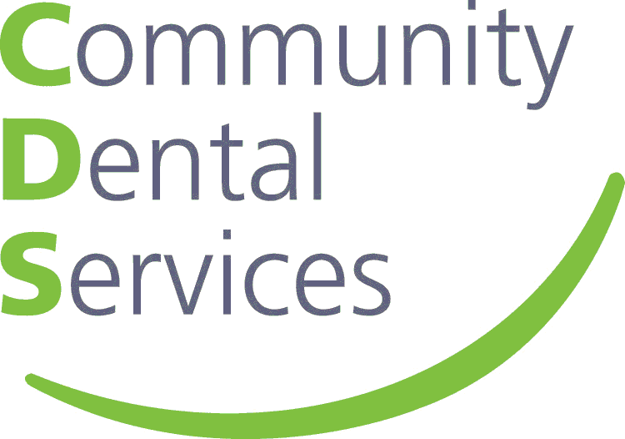

**JOB DESCRIPTION**

**Job Title:** Advanced Clinical Dental Nurse (Mobiles)

**Managed by:** Strategic Mobiles Lead

**Accountable to:** Chief Operating Officer (East of England)

**DBS – Required:** Yes

**Job Summary**

The post holder will be an Advanced Clinical Dental Nurse working in multi-disciplinary teams and supporting the treatment of people who are unable to accept routine dental care because of some physical, intellectual, medical, emotional, sensory, mental or social impairment or a combination of these factors.

They will undertake autonomous dental nurse-led clinics and provide treatment to patients within their extended scope of practice.

The post holder will engage in referral to their own clinic, make referrals as appropriate and refer back to referrer as required to maintain high quality patient care in an efficient process.

The role will deliver clinical training, including undergraduates and dental hygiene / therapy students across CDS, as well as the preparation of coursework.

Travel will be required as travelling across the SNEE area at various venues alongside the mobile dental unit; therefore, a car driver is essential.

**Key Relationships:**

* All members of the clinical teams
* Operational Leads
* Clinical Director
* Educational Establishments
* Workforce Development Team
* External Stakeholders
* Other Health Care Professionals

**Key Duties and Responsibilities:**

1. Provide clinical support to dental practitioner during procedures including undergraduates and dental hygiene / therapy students.
2. The application of topical fluoride varnish following a suitably trained dental registrant prescribed treatment plan.
3. Takes referrals from other dental registrants for treatment with their scope of practice.
4. Undertakes advanced dental nurse (post-certificate) procedures in dental nurse led clinics, within scope of practice which may include taking of radiographs, placing topical fluoride, taking Cone Beam Computed Tomography (CBCT), gives oral hygiene instruction.
5. Assist with dental conscious sedation with a suitable qualified dental registrant.
6. Deals with referrals from outside CDS and where appropriate refers patients onto other colleagues and then back to referrer following investigations.
7. Communicates condition related information to colleagues.
8. Responsible for carrying out clinical training and assessment of undergraduates, dental hygiene / therapy students and dental nurses as required, and contributing to Continuing Professional Development and clinical governance initiatives.
9. Communicates with other health care professions outside of dentistry.
10. Identifies urgent cases and triages referrals. Provides pre- and post-operative advice and instruction for dental procedures, including booking, organisation and the treatment of patients on a 1:1 basis.
11. Proactively supports and engages with the full oral health team.
12. Organises repair of complex equipment.
13. Takes the lead role in audits and Quality Initiative projects.
14. Handles cash from sale of oral hygiene products; assembles and dismantles equipment, ensures all equipment available; orders supplies, contributes to development of service contracts.
15. Clinical supervision and training of dental nurses across CDS, to ensure the provision of an efficient and effective service.
16. Liaises with Senior Dental Nurses across CDS to ensure there is adequate skill mix within clinical teams and employee levels are fit for purpose.
17. Assist in the provision of a wide range of dental treatment in a range of settings, including sedation, general anesthesia, dental clinics and mobiles, domiciliary and hospitals.
18. Utilises knowledge of medically compromised patients, to ensure that dental nurses are supported to treat this group of patients.
19. Complies with all CDS Policies and Procedures at all times.
20. Actively promotes CDS Values and Behaviours in all aspects of the job role.

*The duties and responsibilities outlined in this job description although comprehensive are not definitive and you may be required to perform other duties at the request of your manager.*

*This job description is designed to reflect duties currently incorporated in this post. These may change in the light of changes in the service by CDS. Any such changes will be fully discussed with the post holder.*

**RELEVANT ROLE FACTORS**

|  |  |
| --- | --- |
| **Information Required** | **Completed as appropriate for the role** |
| **Physical**  Examples - the nature, level, frequency and duration of the physical effort required for the job e.g. Kneeling, crouching, work in confined space, sitting, standing, walking, lifting, pulling, running, pushing. | Assembly and use of dental equipment, use of micro skills for patient care  Stands for long periods, moves equipment, manoeuvres patients |
| **Mental**  Examples - the nature, level, frequency and duration of the mental effort required for the job e.g. Checking documents, calculations, analysing statistics, operating machinery, microscope work, assessing patients, formal minute taking, and teaching.  Also measures whether the post holder will be subject to interruptions | Concentration required when assisting dental practitioner; for course preparation and delivery of clinical training |
| **Emotional**  Examples - the nature, level and frequency of emotional effort required to undertake clinical or non-clinical duties that are generally considered to be distressing and/or emotionally demanding. E.g. giving un-welcome news to staff/patients, dealing with difficult situations / circumstances or, caring for the terminally ill, typing / processing reports / letters transmitting highly distressing events, managing major change etc. | Supports clients and their parents, carers with e.g. learning disabilities, challenging behaviour |
| **Working conditions**  Examples - the nature, level, frequency and duration of demands arising from adverse environmental conditions and hazards which are unavoidable and required for the job. E.g. Frequent use of a VDU, exposure to extreme temperatures, working at heights, unpleasant smells, dust / dirt, aggression, noxious fumes, chemical spills, fleas, lice, body fluids, foul linen.  It also includes any exposure to aggressive / challenging behaviour | Exposure to bodily fluids |

**PERSON SPECIFICATION**

**Job title:** Advanced Clinical Dental Nurse

| **Factors** | **Essential requirements** | **Desirable requirements** | **Measurement**  eg *Application /*  *Assessment /*  *Interview* |
| --- | --- | --- | --- |
| **Education and Qualifications** | Registered with the General Dental Council  Degree level qualification or equivalent experience  NEBDN Certificate in Oral Health Instruction or equivalent  NEBDN in Special Care Nursing or equivalent  NEBDN Certificate in Dental Radiology or equivalent  NEBDN Certificate in Topical Fluoride Application or equivalent | Level 3 Award in Education or Training or equivalent;  Assessment and Quality Assurance qualification or equivalent  Certificate in CBCT Level 1 and 2 or able to achieve qualification within the first two years of employment  NEBDN Certificate in Dental Sedation Nursing or equivalent | Application form |
| **Knowledge** | Knowledge of range of complex dental nursing procedures acquired through training and experience  Awareness of the principles of training, teaching and coaching  Evidence of continuing professional development in line with GDC requirements  Sound knowledge of national evidence based guidelines |  | Application /  Interview |
| **Experience** | Evidence of post dental nurse qualification experience working within CDS  Supervisory experience of clinical employees  Experience of coaching/mentoring and preparing presentations  Experience of working with ‘special needs’ patients/clients  Experience with conscious sedation and general anaesthetic sessions/domiciliary visits  Management experience |  | Application /  Interview |
| **Skills and Ability** | Good communication skills  Time management and demonstrable organisational skills  Proficient IT skills including Microsoft Office 365 including Word, Excel, Outlook and Power Point  Significant motivational skills  Ability to empathise, reassure  Involved in Quality Assurance Projects or Audit | Involved in research or scientific publications | Application /  Interview |
| **Personal Qualities** | Ability to work well within a team  Willing to provide support for CDS initiatives which may include occasional evening/weekend working.  Flexibility i.e. with changing priorities  Travel will be required; therefore, a car driver is essential.  Member of a National Representative Organisation |  | Application/  Interview |